Diagrama pachetelor backend

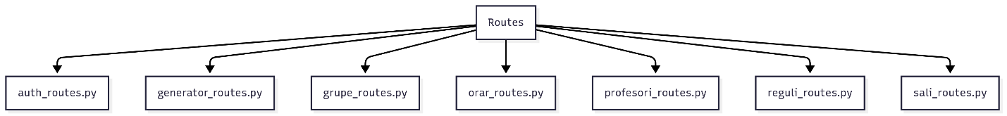

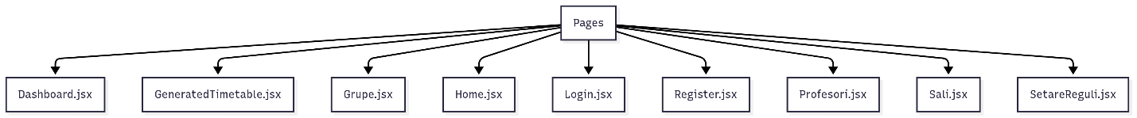

Diagrama claselor backend

Diagrama de clase frontend

Diagrama de structura

Diagrama de componente

Diagrama de activitate



Comunicare   
